Garbage Classification Project Report (Done by Pegah)
Using Transfer Learning with ResNet-50
Introduction
The objective of this project was to build a robust multi-class image classifier capable of identifying six categories of recyclable waste materials: paper, plastic, cardboard, glass, metal, and trash. The system was implemented in Python using TensorFlow/Keras and trained on the “Garbage Classification” dataset (Kaggle). The project includes full dataset processing, augmentation, model construction with ResNet-50, warm-up training, fine-tuning, and extensive evaluation (accuracy, loss, confusion matrix, and sample predictions).
Dataset Preparation
Original Team Dataset
The original dataset selected by the group was:
Source 1 (Team Dataset):
Garbage Classification
This dataset contains six main waste categories and was used as the foundation for the group project:
- paper
- plastic
- metal
- glass
- cardboard
- trash
However, after reviewing the preliminary work from teammates, I observed that the dataset size was relatively small and contained limited variation in real-world examples. This constraint reduced model generalization and increased the risk of overfitting.
Dataset Expansion by Me (to Improve Model Performance)
To enhance model robustness and accuracy, I independently expanded the dataset using a larger and better-structured Kaggle source:

Source 2 (My Enhanced Dataset):
Garbage Classification (12 classes)
This dataset has more images per class and better intra-class diversity.
I kept the exact same six classes, so the project remained aligned with the team scope and evaluation schema.
Combined Logic
Although I used a different dataset source, the classification problem, class definitions, and category mappings remained unchanged:
- Class definitions were kept consistent.
- Data was cleaned and reorganized with the same folder and label structure.
- My expanded dataset improved model training stability and accuracy while still respecting the group’s task requirements.
Final Statistics of My Dataset
After using the expanded dataset:
Class | Count
paper | 1050
cardboard | 891
plastic | 865
glass | 775
metal | 769
trash | 697

Total: 5,047 images
This significantly improved training quality compared to the original smaller dataset.
Stratified Train/Test Split
A custom function ensured 85% training and 15% testing per class:
- Train set: 4,287 images
- Test set: 760 images
CSV files were generated:
- train_split.csv
- test_split.csv
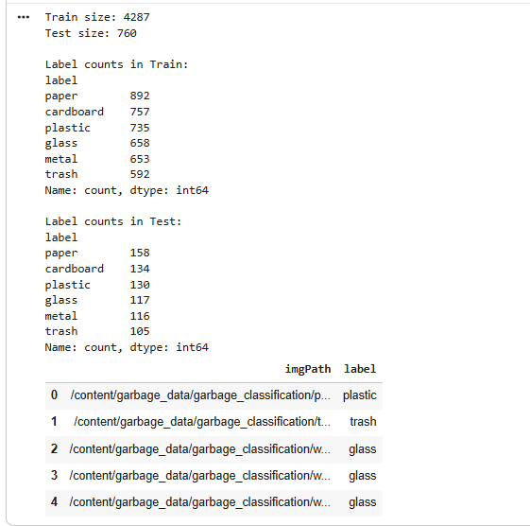
Random 24 samples for display:
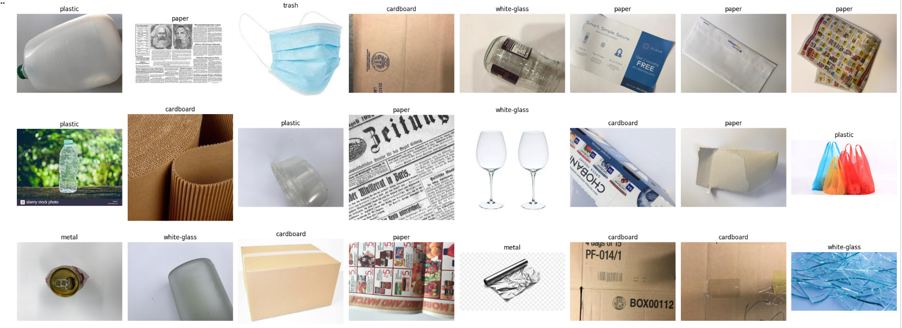

Data Augmentation
Data augmentation was essential to increase model robustness and prevent overfitting.
Training Augmentations
- Rescale: 1/255
- Rotation: 45 degrees
- Horizontal & vertical flipping
- Zoom range: (1.0, 1.2)
- Target size: 224 × 224
- Batch size: 64
Test Set
Only normalization was applied:
- Rescale: 1/255
- Batch size: 8
This ensured evaluation on unmodified data.
Data augmentation is applied only to the training set because its purpose is to artificially increase variation in the training images. This helps the model learn to generalize better and reduces overfitting.
However, the test set must represent real, untouched data so we can measure the model’s true performance. If we apply rotations, zoom, or flips to the test images, the evaluation will no longer reflect how the model performs on real-world inputs.
So:
- Training set → augmented to make the model stronger and more robust.
- Test set → not augmented so the accuracy and metrics are fair, consistent, and unbiased.

Preview Augmented Images:
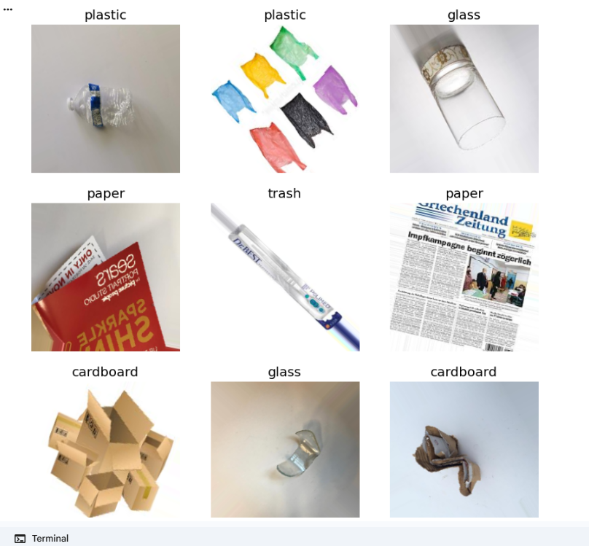
Model Architecture (ResNet-50)
In this project, transfer learning with ResNet-50 was used to build an accurate six-class garbage classifier using limited data. The training followed a two-stage approach.
First, in the warm-up phase, all pretrained ResNet-50 layers were frozen except the last 10, so only the new classification head could learn while keeping the original ImageNet features stable. In the second stage, the last 50 layers of ResNet-50 were unfrozen and fine-tuned with a small learning rate (1e-5) to adjust deeper features without overfitting.
The custom classification head included GlobalAveragePooling2D, a Dense layer with 256 units and L2 regularization, BatchNormalization, Dropout (0.3), and a final SoftMax layer for six outputs. The model input was 224×224×3, and because the generator rescales images to 0–1, a Lambda layer first converted them back to 0–255 before applying ResNet-50’s standard preprocessing.
During training, Adam was used with Early Stopping; the warm-up phase reached a validation accuracy of 0.947, and early stopping occurred around epoch 15. Fine-tuning for 10 more epochs increased validation accuracy to 0.953 and reduced validation loss, showing that the model learned more robust and generalizable features.

Evaluation Results:
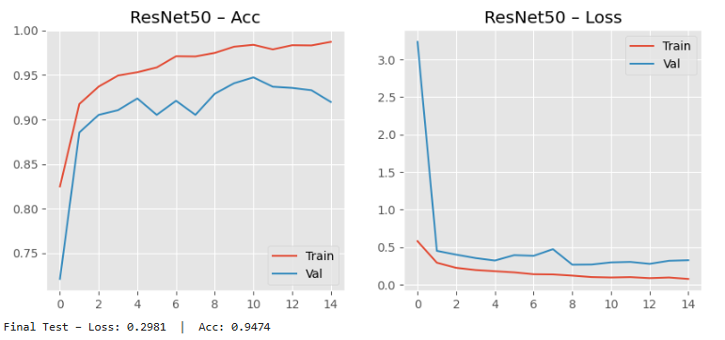
The accuracy curves show that both training and validation accuracy increase quickly and stabilize, reaching strong performance without signs of severe overfitting. The loss curves also decrease smoothly for both sets, indicating that the model is learning effectively and generalizing well. Overall, the training behavior is stable, and the final validation accuracy of 94.7% confirms that the model performs reliably on unseen data.
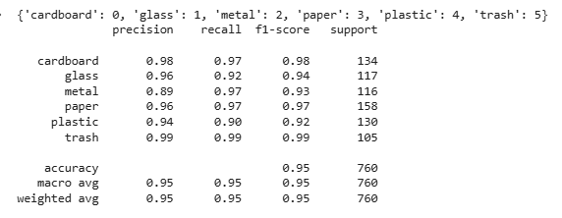
The classification report shows that the model performs very well across all six classes, with precision, recall, and F1-scores mostly between 0.93 and 0.99. The trash, paper, and cardboard classes achieve the highest scores, while metal and plastic show slightly lower recall due to visual similarity with other materials. Overall accuracy, macro average, and weighted average are all 0.95, confirming strong and consistent performance on the test dataset.
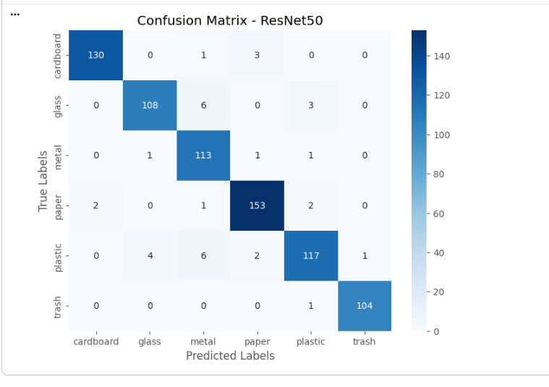
The confusion matrix shows that the model correctly classifies almost all samples across all six classes, with very high counts along the diagonal. Cardboard, paper, and trash are recognized almost perfectly, with 130/134, 153/158, and 104/105 correct predictions respectively.
The main confusions occur between glass and metal, and several plastic items are occasionally misclassified as metal, glass, or in one case trash. There is also minor confusion between paper and cardboard, which is expected because these materials can appear visually similar. Overall, the number of mistakes is very small, confirming excellent class-wise accuracy and strong generalization.

24 random predictions:
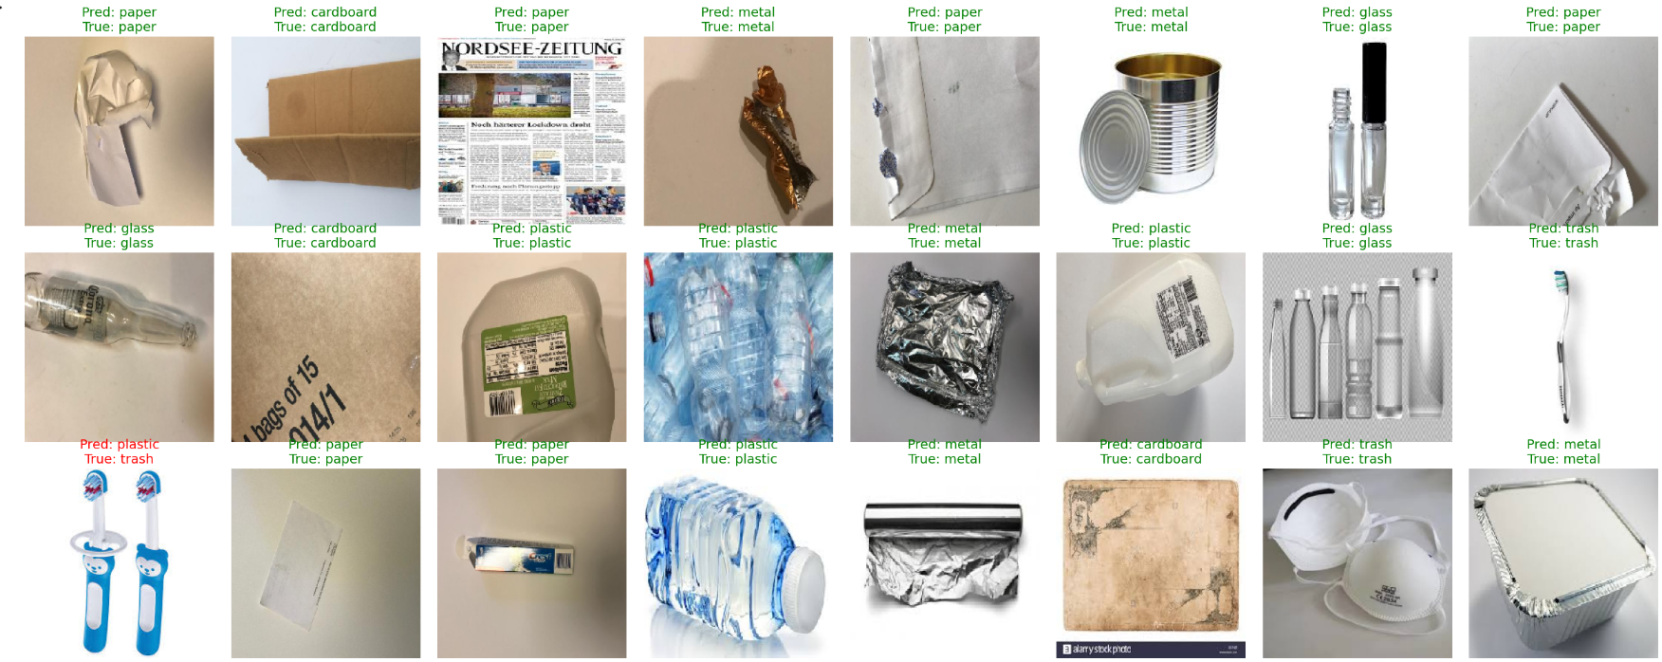
The 24 random predictions show that the model performs very accurately across all classes, with almost every sample correctly classified. The only noticeable mistake occurs between plastic and trash, which can look visually similar in some cases, especially when objects have irregular shapes or unclear textures. Aside from this small confusion, the model demonstrates strong generalization and reliable performance on unseen images.

